Centralia Sand LLC quarterly pricing. 4/1/2025

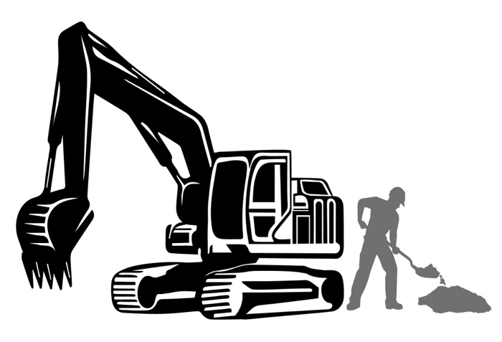

Second quarter pricing of 2025
(In cubic yards / Price includes taxes and fees)

- A3 / fill dirt = $6.75
- MSE = $9
- Scrapings = $4.50
- Topsoil = $9

*Scrapings, MSE, and topsoil must be ordered in advance.

CONTACT FOR BULK PRICING!

Operated by:

