Centralia Sand LLC quarterly pricing. 1/1/2025

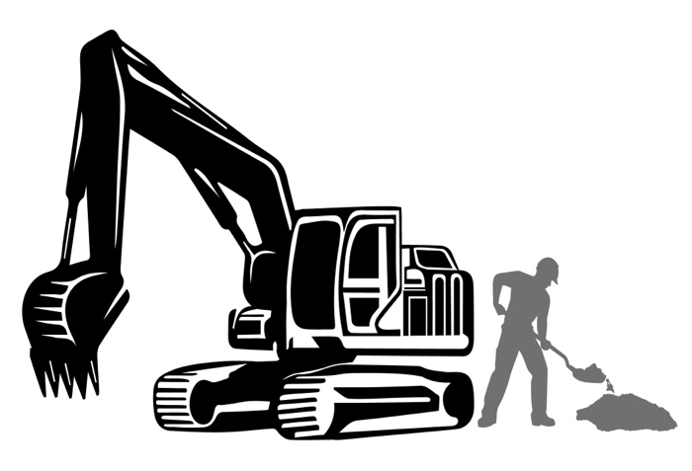

First quarter pricing of 2025
(In cubic yards / Price includes taxes and fees)

- Structural fill dirt = $6.75

*Scrapings, A-3, MSE, and topsoil must be ordered in advance.

CONTACT FOR BULK PRICING!

Operated by:

